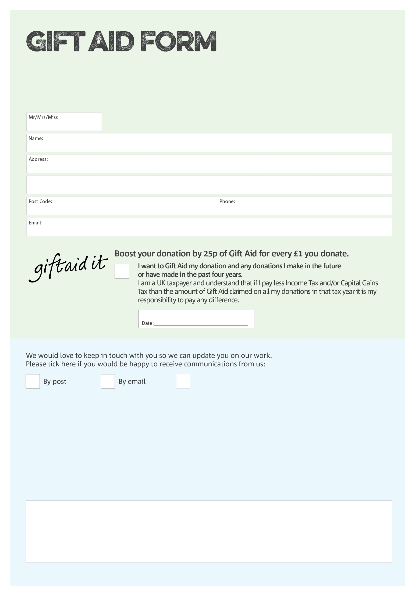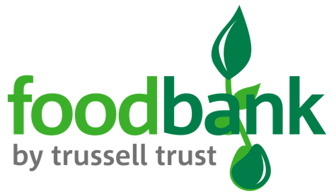

By filling in this form Collier Row & Romford Foodbank will receive an extra 25p for every £1 you give at no extra cost to you. Thank you!

Registered Charity no. 1172326 Registered in England & Wales

**Data protection**

*Collier Row & Romford Foodbank is committed to protecting your privacy and will process your personal data in accordance with current Data Protection legislation. Collier Row & Romford Foodbank collects information to keep in touch with you and supply you with information relating to our work. To unsubscribe from our newsletter, send a message to the email address above with the word unsubscribe in the subject line. A full data privacy statement for financial donors is available from the foodbank on request.’*

You can change your preferences any time by contacting us on 07548 674958 or emailing us at

info@collierrowromford.foodbank.org.uk

I do not wish to receive future communications from Collier Row & Romford Foodbank

We would love to know why you have chosen to donate to Collier Row & Romford Foodbank. If you would like to share your motivation let us know below: